

BRACT Vishwakarma Institute of Information Technology, Pune

Department of Artificial Intelligence and Data Science

**Viz-A-Thon**

**in Collaboration with**



| Team Id: 30 | Team Name: Carpe Diem |
| --- | --- |
| College name: BRACT’s Vishwakarma Institute of Information Technology, Pune | |
| Number of members in a team: 4 | Problem Statement Id: 1 |

**Team members details**

| Name | Mobile Number | Mail Id |
| --- | --- | --- |
| Faiz Saiyad | 8177941560 | fsaiyad990@gmail.com |
| Jyotirmay Khavasi | 9987540788 | jyotirmay.22010699@viit.ac.in |
| Pratham Raka | 9511660800 | prathamraka001@gmail.com |
| Saiprasad Mane | 9067564561 | saiprasad.22010642@viit.ac.in |

**INDEX**

| **Sr. No.** | **Contents** | **Page No.** |
| --- | --- | --- |
| **1** | **TITLE/ PROBLEM STATEMENT** | **2** |
| **2** | **OUTPUT SCREEN SHOTS WITH EXPLANATION** | **3** |
| **3** | **TWITTER HANDLE** | **7** |
| **4** | **SKILLS USED, LEARNINGS AND TOOLS FUNCTIONALITIES** | **7** |

**Problem Statement:**

Analysis of Hypothetical Business Problem using Flipkart Dataset

The objective is to address a hypothetical business problem for a Flipkart Perform detailed analysis of each brand.

Dataset - Flipkart Mobile DatasetAuthorized Seller. According to the problem the individual is looking to sell cell phones on Flipkart. For this, the seller is looking for the best product, brand, specification and deals that can generate the most revenue with the least amount of investment and budget constraints.

Questions to be answered:

* Should he simply sell products for one brand, or should he try to sell models from various brands?
* Using Data Visualization find out insights and relation between different features.

**Visualizations and Insights:**

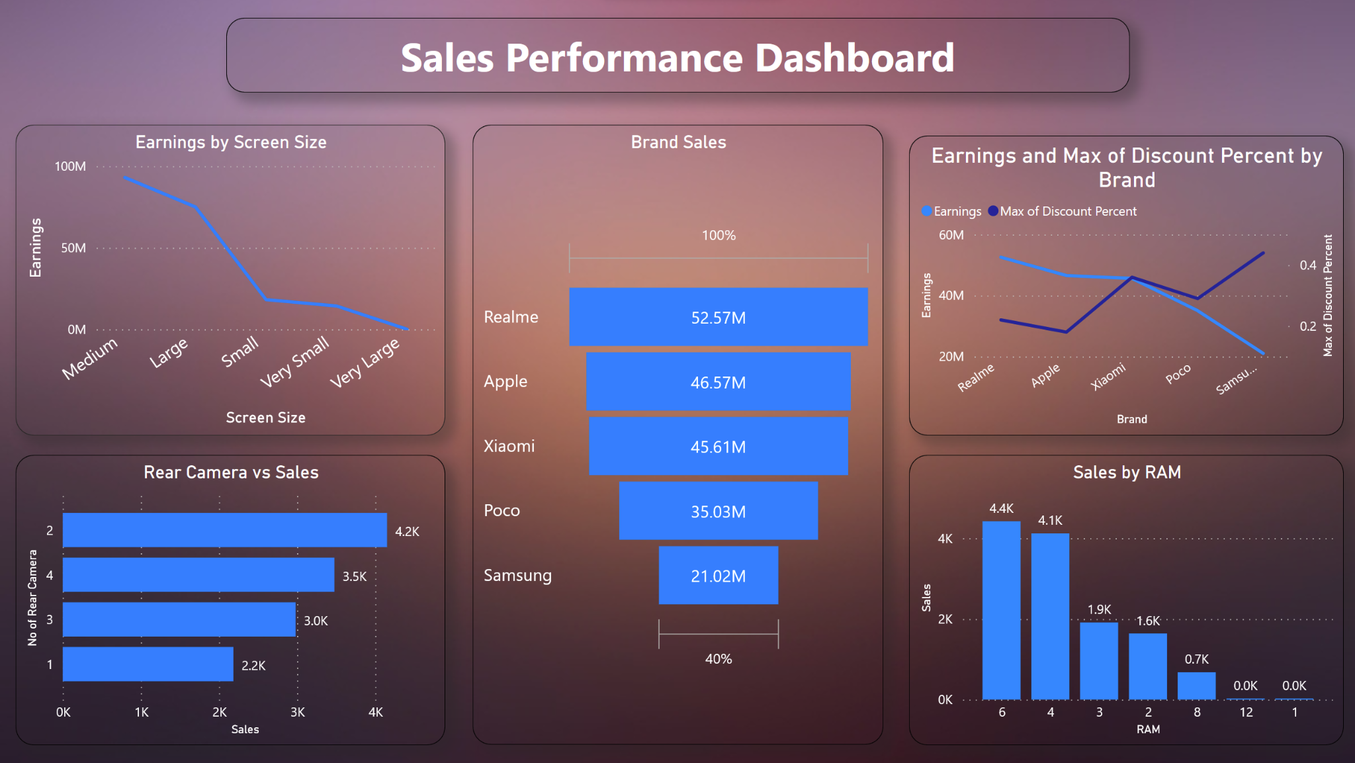

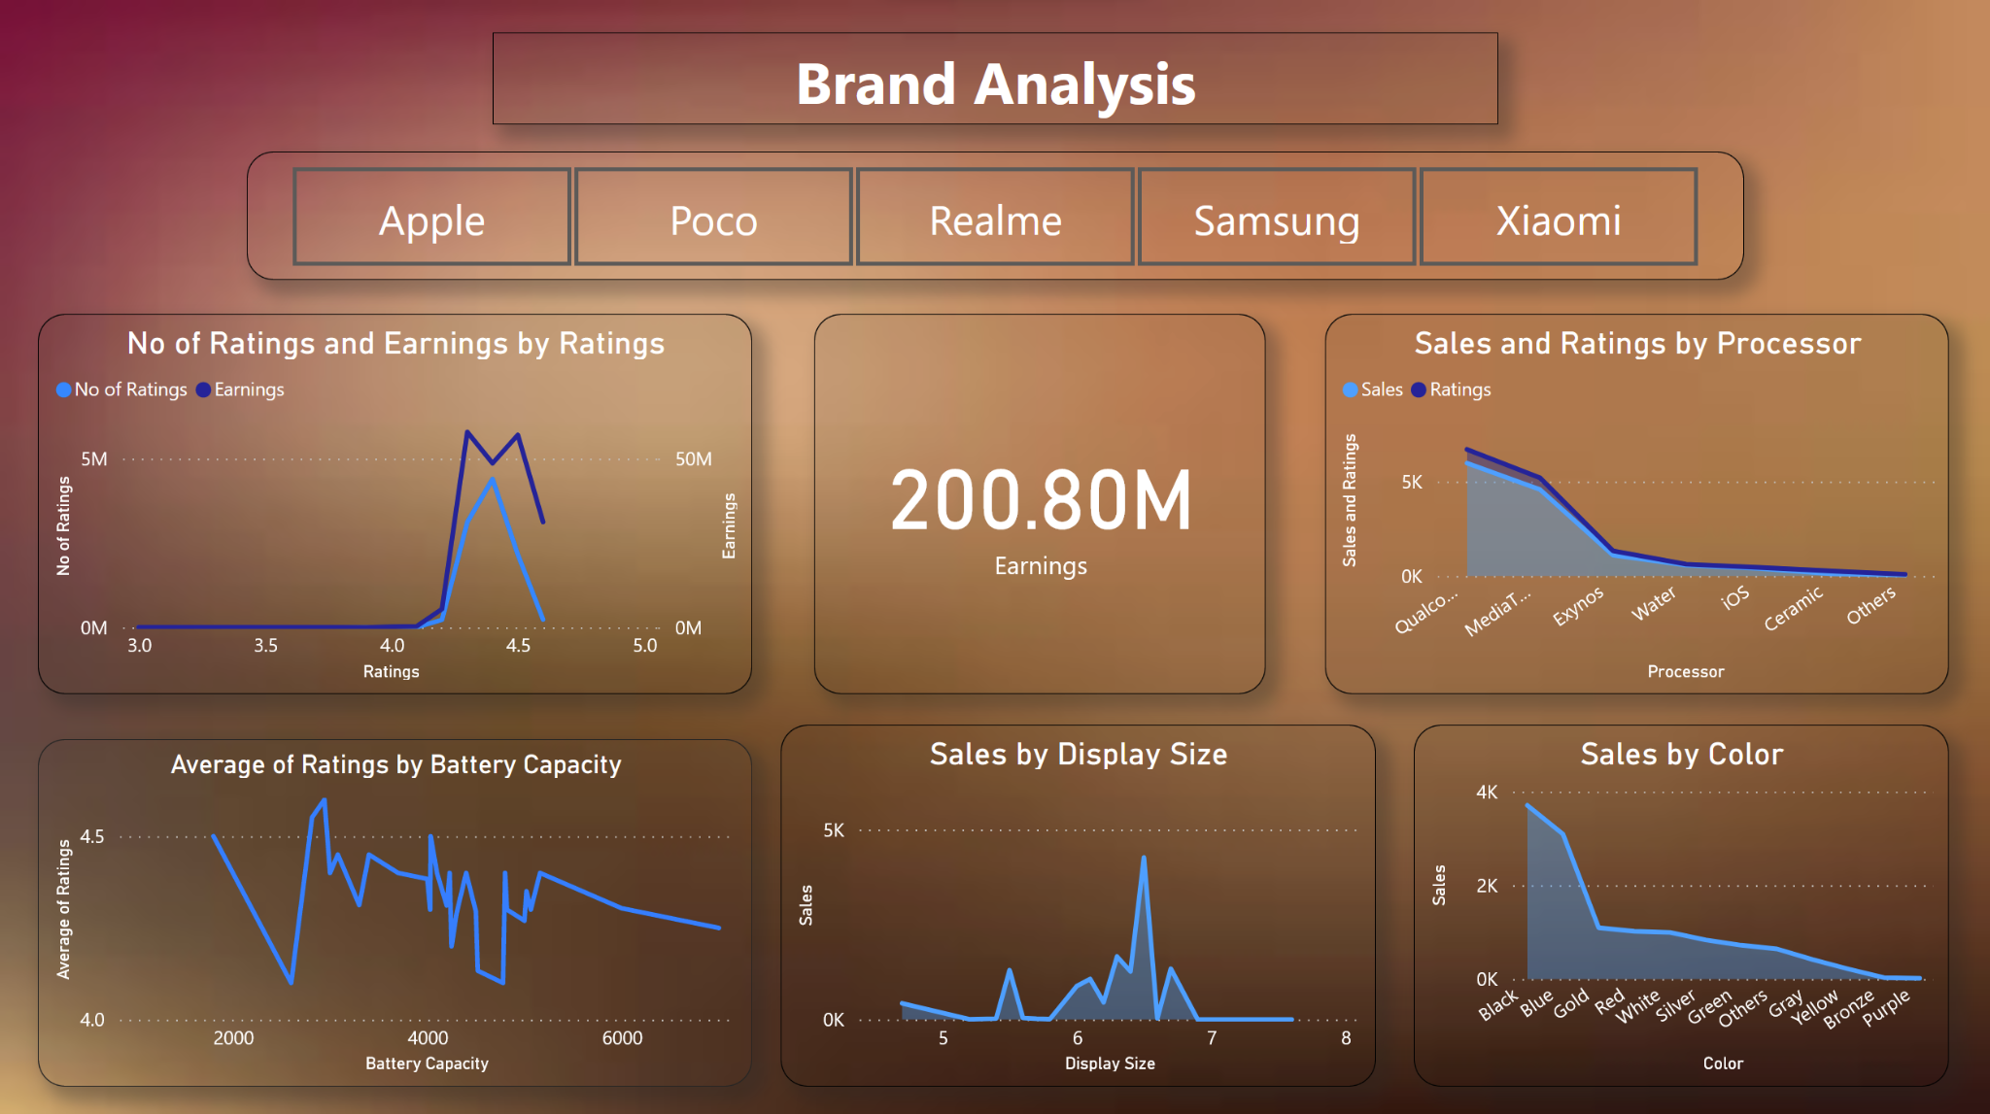

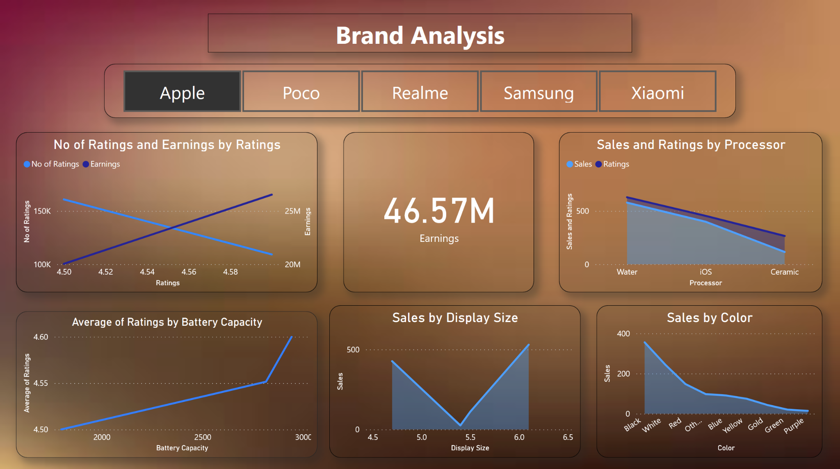

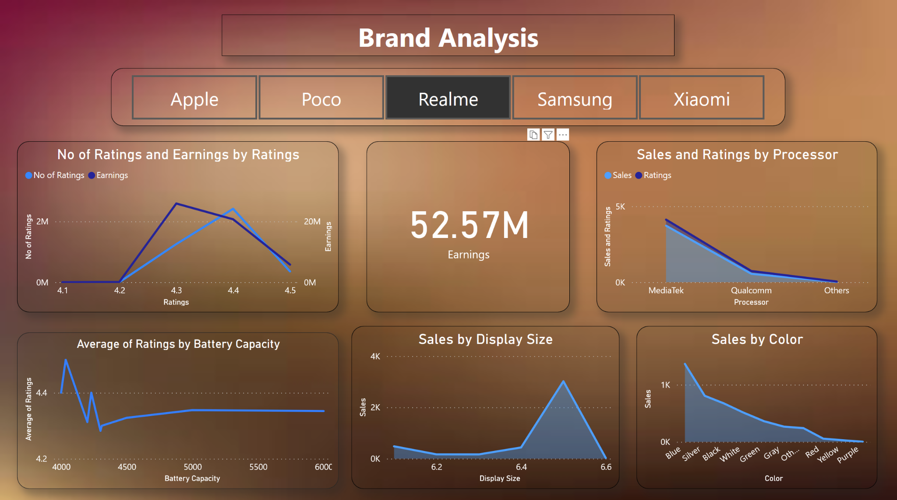

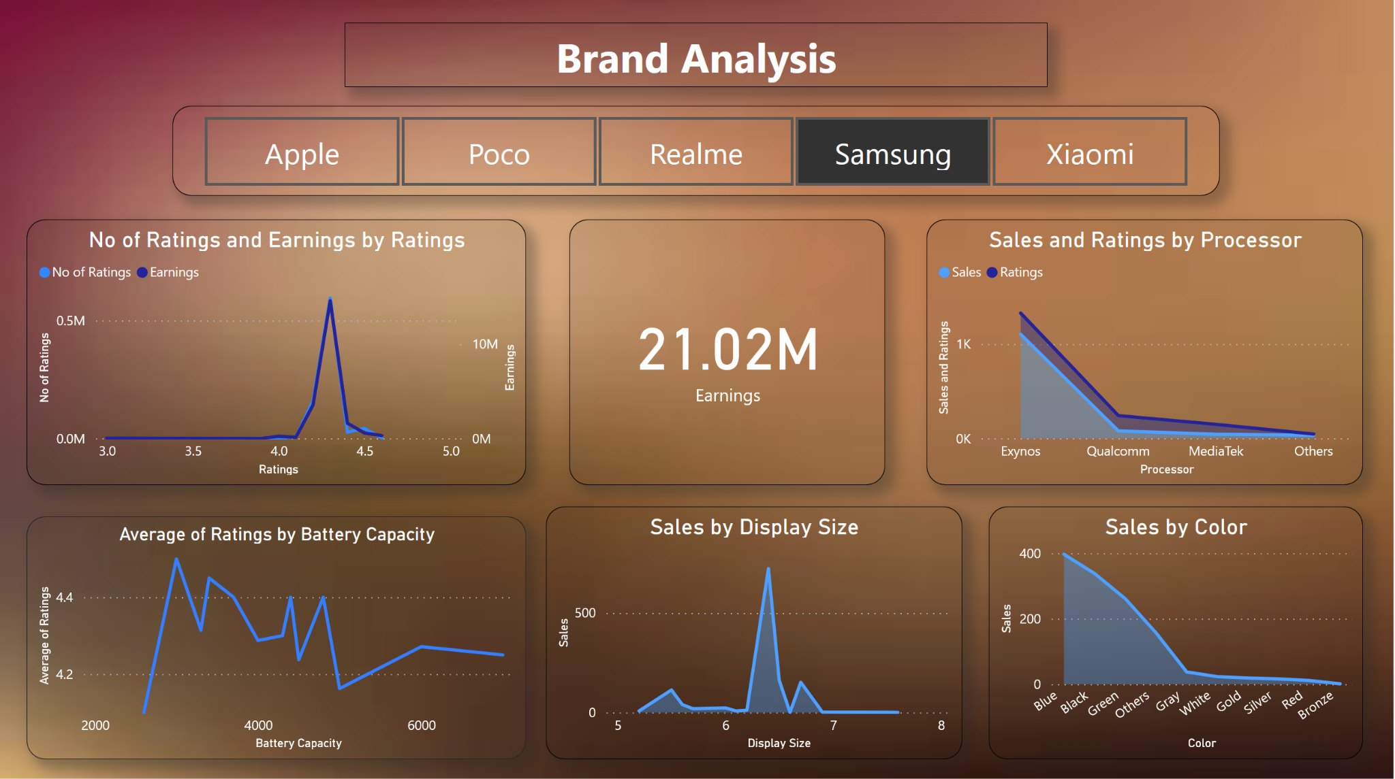

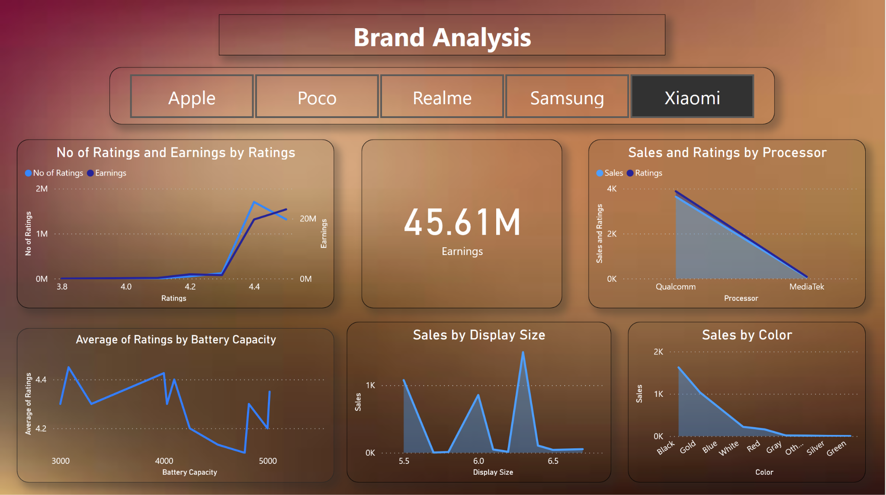

**Q: Whether to be exclusive to one brand or be a varied seller?**

According to the overall brand performance, being a varied seller has higher margins for sales and profit. Exclusivity towards one brand limits the sales for a specific demographic.

**Overall Analysis:**

RealMe seems to have the maximum number of sales followed by Xiaomi, while Samsung has the largest price by brand. It can also be seen that most of the processors support 4 Gb Ram and hence the sales of the 4 Gb Ram is significant followed by 6 Gb Ram models. In the perspective of the sales person to get the most revenue, he has to sell 4Gb and 6Gb ram Models from various brands.

It can also be seen that colors are also given preference on the basis of Ram Size. The 6Gb Ram Have the highest sales, but the highest sales in the color of the 6Gb Ram is Blue, followed by Black. For the 4Gb Varient of different models of different brands, the highest sales is of the Color Black followed by Blue. So for the sales person to get the most revenue, he has to stock 6Gb ram Blue phones with Qualcomm Processors by Realme or Xioami, followed by 4Gb Ram varients of different brands and models of color Blue

**Q: Relationship between sales and features**

**Processors** have an indirect but significant effect on the sales and ratings. The lower rated smartphones all had either Exynos or Ceramic processors. The most preferred processor with the best ratings and the most brands supporting it is the Qualcomm. The Apple smartphones have processors exclusively from the iOS lineup.

**Discount** seems to have an inverse effect on the earnings. The larger the discount, the more the earnings seem to have fallen as is evident in the case of Samsung.

In terms of **Screen Size**, the ones with the medium size seem to be preferred by most, as is shown by the sales. This is the same in case of **RAM**, where a moderate amount is selling the most units.

It can be seen that 5000mah **Batteries** are the highest rated and the most selling Hence The Shopkeeper should Stock 5000mah Batteries of various brands and models, prioritizing Qualcomm and MediaTek Processors, Black color followed by Blue for the 6Gb variant, followed by Blue and Black Color for the 4Gb variant

**Q: Brand Analysis**

**Apple**

Apple is the second highest earning brand of the 5, even if the number of units sold is less in comparison to the others. This is because of the higher price of each unit.

**Xiaomi**

Xiaomi have quite high sales for display size between 6 to 7 and also have high sales for black colour and qualcomm processor.

**Samsung**

qualcomm

**Realme**

Realme has the highest overall sales as well as the highest overall earnings. They are offering budget oriented smartphones.

**Poco**

Sales for the poco brand are largely dependent on display size and colour.

The black coloured phone has more sales than other colour phones.The sales for mobile of poco is more for qualcomm processor.

[Visualization Link](https://app.powerbi.com/groups/me/reports/bd170fcc-205b-4c0e-b912-241d84e7d9b0/ReportSection590ae542684f8015a4bb)

**Twitter Handle:**

Carpe Diem ( @CarpeDi69348799 )

**Skills used, Learning and Tool Functionalities:**

The skills and tools used include:

* PowerBI
* Creation of a separate table for better visualizations
* Creating aggregates and measures for various values

Learnings:

* Learnt how to use PowerBI to get insights in limited time
* Team Coordination